Part 1

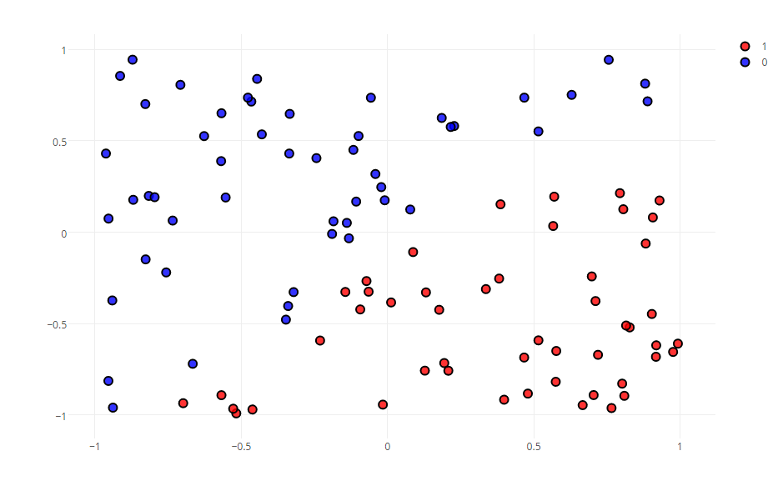

Part 2

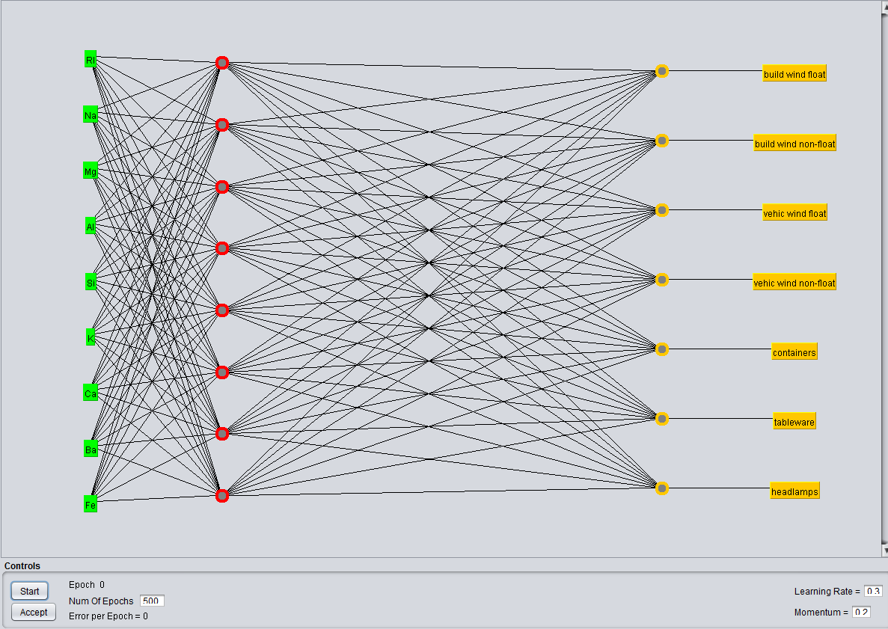

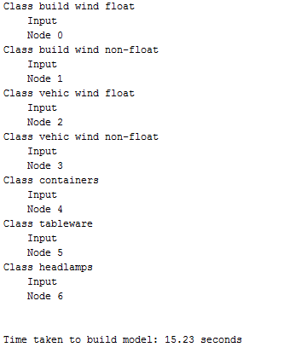

An ANN is relatively easy to understand and model, in comparison to statistical methods. It doesn’t require much informational background like the statistical ones. This is widely used in classification and forecast problems. The problem is that ann is a black-box learning, causing problems when interpreting the relationship between the input and output, and cannot deal with uncertainties.